R
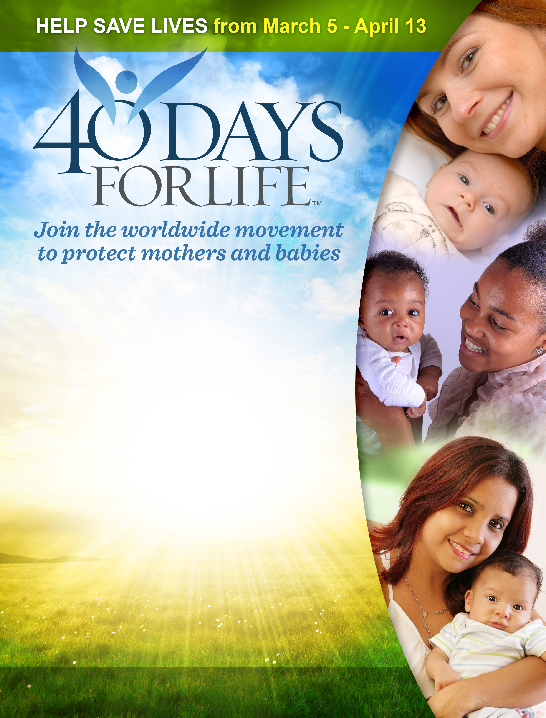
ecognizing that “with God, all things are possible,” our community is joining with hundreds of other cities for this spring’s global 40 Days for Life – one of the largest internationally coordinated pro-life mobilizations in history.
40 Days for Life is a peaceful, prayerful – and proven effective – pro-life campaign that has already been embraced by more than 600,000 people worldwide, saved 8,245 lives from abortion, led to the conversion of 88 abortion workers, and seen 44 abortion facilities close down for good.
40 Days for Life features three components:
- PRAYER & FASTING: Join together with other believers for 40 days of fervent prayer and fasting for an end to abortion.
- PEACEFUL VIGIL: Stand for life during a 40-day peaceful public witness outside the Fort Lauderdale Women's Center at 2001 W. Oakland Park Blvd.
- COMMUNITY OUTREACH: Bring a positive pro-life message to every corner of our city through media efforts, advocacy and public visibility
Learn how you can “speak up for those who cannot speak for themselves” right here in Fort Lauderdale by contacting Tewannah Aman at 754-244-4135 (cell) and/or via email at mail@browardrighttolife.org, or by visiting the webpage shown below.
www.40daysforlife.com/fortlauderdale

